School:

Student Name/ID:

Student Grade:

Assessment Date:

Middle School Student Self-Report (SSR) Results

**6th - 8th**

**Invite your student to reflect on their assessment experience and results by using these guiding questions:**

* What was it like completing the assessment?
* What areas did you score the highest in? What does it look like for you to use those skills?
* In what areas do you have opportunities for growth? What is an area you would like to strengthen?
* Is there anything you feel would be helpful for others to know as they support you?

DESSA assessments report results using T-scores, which are categorized into three descriptive ranges: Strength, Typical, and Need for Instruction.

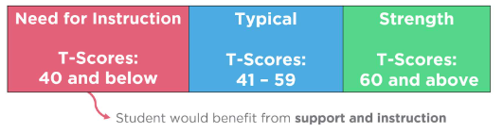

**DESSA Scores:**

DESSA assessments report results using T-scores, which are categorized into three descriptive ranges: **Strength**, **Typical**, and

**Need for Instruction**.



| © 2025 Riverside Insights

|  |  |  |
| --- | --- | --- |
| **Skill** | **T-Score** | **Range** |
| **Optimistic Thinking**  Optimistic Thinking is the belief and demonstration of confidence, hopefulness, and positive thinking regarding oneself, others, and one’s life situations in the past, present, and future. |  |  |
| **Self-Awareness**  Self-Awareness is the ability to understand emotions, thoughts, and values and how they influence one’s behavior; recognize strengths and limitations; and develop healthy identities and a sense of purpose. |  |  |
| **Self-Management**  Self-Management is the ability to manage emotions and behaviors across different situations and environments and to demonstrate agency as one works to set and achieve personal and collective goals. |  |  |
| **Social Awareness**  Social Awareness is the understanding of social norms for behavior; the ability to empathize with, respect, and take the perspectives of others; and the feeling of connection and belonging with family, peers, schools, and community groups. |  |  |
| **Relationship Skills**  Relationship Skills are the abilities to establish and maintain healthy and positive relationships, including effective communication, collaborative problem solving, negotiating conflict, and demonstrating helpful and supportive behaviors. |  |  |
| **Responsible Decision Making**  Responsible Decision Making is the ability to make careful, reliable, and constructive choices about personal and social behavior that are appropriate across diverse situations; to consider the personal, social, and collective impact of one’s actions; and to demonstrate curiosity and an open-mindedness to learning. |  |  |
| **Social-Emotional Composite**  An overall indication of the strength of the youth’s self-reported social and emotional competence |  |  |

***Note:*** *Students have access to their assessment scores, which are displayed differently than the t-scores and descriptive ranges included on this document. The term****Need for Instruction****was thoughtfully chosen to convey that a student has not yet acquired these skills. This score increases the awareness that a student requires support and instruction for their continued development and time to practice these skills.*