School:

Student Name/ID:

Student Grade:

Assessment Date:

High School Student Self-Report (SSR) Results

**9th - 12th**

**Invite your student to reflect on their assessment experience and results by using these guiding questions:**

* What was it like completing the assessment?
* What areas did you score the highest in? What does it look like for you to use those skills?
* In what areas do you have opportunities for growth? What is an area you would like to strengthen?
* Is there anything you feel would be helpful for others to know as they support you?

DESSA assessments report results using T-scores, which are categorized into three descriptive ranges: Strength, Typical, and Need for Instruction.

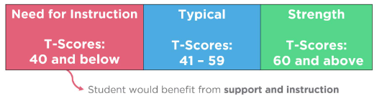

**DESSA Scores:**

DESSA assessments report results using T-scores, which are categorized into three descriptive ranges: **Strength**, **Typical**, and

**Need for Instruction**.



| © 2025 Riverside Insights

|  |  |  |
| --- | --- | --- |
| **Skill** | **T-Score** | **Range** |
| **Self-Awareness/Optimistic Thinking**  A youth’s realistic understanding of their strengths and limitations and consistent desire for self-improvement. A youth’s attitude of confidence, hopefulness, and positive thinking regarding themself and their life situations in the past, present, and future. |  |  |
| **Self-Management**  A youth’s success in controlling their emotions and behaviors, to complete a task or succeed in a new or challenging situation. |  |  |
| **Social Awareness**  A youth’s capacity to interact with others in a way that shows respect for their ideas and behaviors, recognizes their impact on them, and uses cooperation and tolerance in social situations. |  |  |
| **Relationship Skills**  A youth’s consistent performance of socially acceptable actions that promote and maintain positive connections with others. |  |  |
| **Goal-Directed Behavior**  A youth’s initiation of, and persistence in completing, tasks of varying difficulty. |  |  |
| **Personal Responsibility**  A youth’s tendency to be careful and reliable in their actions and in contributing to group efforts. |  |  |
| **Decision Making**  A youth’s approach to problem solving that involves learning from others and from their own previous experiences, using their values to guide action, and accepting responsibility for their decisions |  |  |
| **Social-Emotional Composite**  An overall indication of the strength of the youth’s self-reported social and emotional competence |  |  |

***Note:*** *Students have access to their assessment scores, which are displayed differently than the t-scores and descriptive ranges included on this document. The term****Need for Instruction****was thoughtfully chosen to convey that a student has not yet acquired these skills. This score increases the awareness that a student requires support and instruction for their continued development and time to practice these skills.*