Below is a suggested letter from the School District to Families regarding the DESSA. Please edit for your school or organization. Specific areas in need of editing are highlighted in yellow.
You can use this letter as a cover page for batch-printed individual reports, manually fill in results below, or use the Rating Export and a mail merge to populate this letter for each student.
Dear Parent(s) or Guardian(s), [Consider personalizing with the parent name here]
As you may remember, your student was recently assessed by their teacher using the DESSA system. The DESSA is a strength-based assessment that measures your student’s grasp of important skills that will help them grow and succeed throughout their school years and after they graduate from high school. These skills include taking responsibility for their actions, working well with others, and more. You can learn more about DESSA here. Below is a description of the DESSA scores and the next steps for your child based on the results.
Curious about ways you can support these skills at home? Check out the DESSA Parent and Caregiver Portal for ideas.
DESSA Scores
The Social-Emotional Total score is a snapshot of a child’s overall social and emotional skill set.
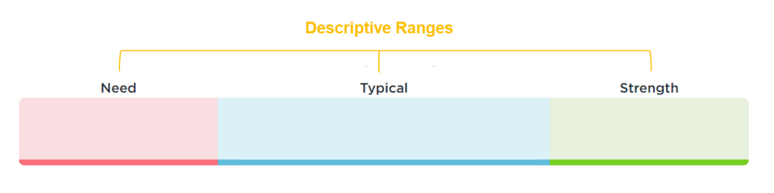

Score | Descriptor | Descriptor Definition | Next Steps for Social and Emotional Skill Development
60 and above | Strength | - The term Strength indicates that your child has well-developed social and emotional skills. | - Support and sustain social and emotional skill-building through classroom lessons and activities.
41-59 | Typical | - The term Typical indicates that your child is demonstrating expected social and emotional skills.  - About 66% of children receive a typical rating. | - Promote social and emotional skill-building through classroom lessons and activities.
40 and below | Need for Instruction | - The term Need for Instruction was thoughtfully chosen to convey that a child needs support and instruction in their social and emotional skill development.  - It reflects that the student has not YET acquired some social and emotional skills. | - [Sample- Full DESSA will be completed. School leaders will develop a plan to support the child’s specific areas of Need for Instruction with parental input].  - [Insert your details for creating a DESSA plan for the student here].

Child’s Name | Rating Window | Social-Emotional Total | Percentile Score | Descriptor
John Smith | Universal Screening Fall/Spring/Winter/Summer  2018-19 | 39 |  | Need

If you have any questions, please feel free to call ____________ at ___________.
Sincerely,
School official

